**EMPLOYEE ATTENDANCE**

**DEFINITION :-**

Develop a java application for Employee Attendance System which covers all the functionalities of Employee’s attendance , track records, early and late punch records, penalty etc. Also add any additional HR functionalities if applicable. Add all operations with databasesupport.

**MODULES**

Our java program contains 5 features .

1.Attendance :-

. Full time

. Half time

. Overtime

. Absent

. Leave

2. Salary :-

. Full salary ( no absentee , no leave )

. Calculated on the number of days worked

. Salary due

3. Calculator :-

. To calculate the salary

4. Salary slip/download salary receipts:-

.Collect the receipt

5. Leave request :-

. Employee can send msg to owner for taking a leave with reason

. So owner can mark on leave on software.

**DIAGRAM**

**USE CASE**

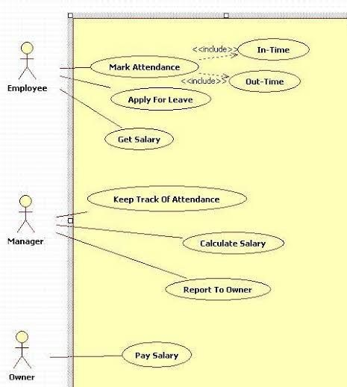

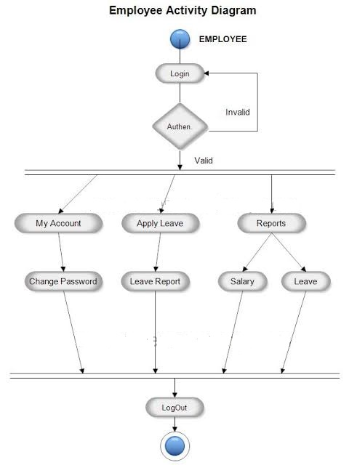

**CLASS DIAGRAM**

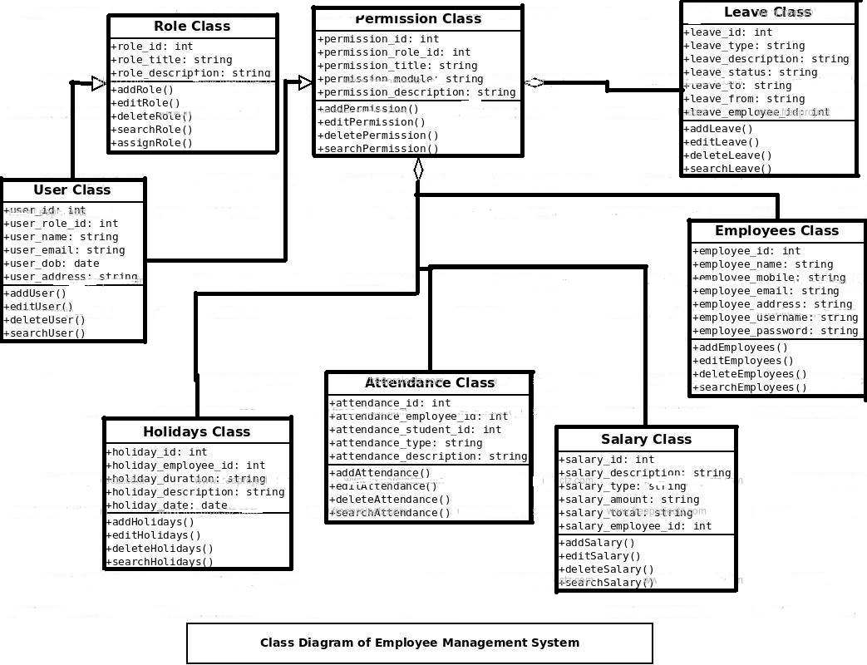

**PREM PARSANIYA – 7107**

**HEMEET VAKHARIYA - 7094**